Combined Chemical Power Plant
Project by Team ANN
Submission Date: 31/07/2019

Shamima Haque Priya
1620069042
Department of Electrical and Computer Engineering
North South University
Dhaka, Bangladesh
Shamima.priya@northsouth.edu

Nabiul Hoque Khandakar
1631164642
Department of Electrical and Computer Engineering
North South University
Dhaka, Bangladesh
nabiul.khandakar@northsouth.edu

Shadman S. Khan
1611918042
Department of Electrical and Computer Engineering
North South University
Dhaka, Bangladesh shadman.khan@northsouth.edu

Ishrat Jahan Ananya
1631636042
Department of Electrical and Computer Engineering
North South University
Dhaka, Bangladesh
ishrat.jahan16@northsouth.edu

Abstract: It is seen that, in today’s time, it is possible to predict the regression relations using artificial networks that has been used to create various model systems to observe changing patterns in non-linear relations. The framework under examination must have enough dataset accessible to prepare the neural system. The center focus of this work is to apply this methods and explore different results and consequences for neutral artificial neural system (ANN) which is used to get relapse model that will predict electrical yield control (EP) of integrated cycle power plant which is dependent on 4 attributes. It indicates additionally higher execution for bigger preparing dataset measure; at the other hand, it demonstrates extraordinary impact of bigger number of factors as the provided information.
Keywords: Neural Networks, Regression, Combined Power Cycle

Introduction
Power is one of the key concepts and one of the fundamental theories for the base of the electrical science. An important factor of an electrical or electronic circuit is its relationship with its power unit. Electric power can be defined as work done divided by time taken. The SI unit of power is WATT (W).
Power plant has been set up to furnish human networks with the required measure of power. Of all the scientific methods, displaying the framework's thermodynamics, AI methodologies can be utilized. One of these techniques is artificial neural systems (ANNs). With the capabilities of the artificial neural systems, it is possible to state the nonlinear connections where the natural factors can contribute towards the improvement of the model. The yield of the model is the power produced by the model. Moreover, given the conditions and the attributes, it is possible to understand and calculate the intensity of the power plant with the ecological conditions providing a change of effect on them.

The aim for the research on this concept is to understand the problems related due to the combined chemicals which is used for the formation of power plants. The new age of joined cycle power plants work at a temperature in the range 53-58%. The issues are aggravated by the expanding requirement for cycling. Huge integrated cycle power plants were initially created as baseload units (one begin in at regular intervals of activity). The truth is that most integrated cycle power plants are working under cyclic conditions where the temperature could be as low as 40-half of the baseload. A considerable lot of these plants presently are being shutdown.
The aim of this research is to verify and experiment various options which is used to obtain the regression model that will predict the electrical output power (EP) of combined cycle power plant and to see the changes that the model will receive for the attributes present in the data set.

Background
After reviewing a recent paper, related to the research, certain information were discovered. This paper “Prediction of Electrical Output Power of Combined Cycle Power Plant Using Regression ANN Model” was written by Elkhawad Elfaki and Ahmed Hassan. The paper was published in June 5, 2018. From intense reading and understanding, the following concepts were highlighted.

• Combined cycle power plant
A combined cycle power plant is a combination of a joined cycle power plant colluded together of heating motors that works in a pair from a similar source of heat, changing over it into mechanical energy, which thus for the most part drives electrical generators. The rule is that in the start of finishing its cycle (in the principal motor), the temperature of the working liquid in the framework is still sufficiently high that a second consequent heating motor concentrates vitality from the warmth that the main motor delivers. By joining these numerous surges of work upon a solitary mechanical shaft turning an electric generator, the general net effectiveness of the framework might be expanded by 50–60%.
That is, from a general proficiency of state 34% (straightforward cycle), to perhaps a general productivity of 62% (joined cycle), 84% Theoretical effectiveness (Carnot cycle)
• Definition of Artificial Neural Network
Artificial Neural Network can be defined as computational based model where the implementations are proceeded based on the structure and functions of biological neural networks. The concepts are similar as the neural network works in manner where it accepts changes and responds to the inputs to provide specific outputs.
ANNs can be used to build structural models to represent nonlinear relations where a pattern can be discovered between complex relationships.

• Advantages of using Artificial Neural Network
1. Data, for example, in traditional writing computer programs is put away on the whole system, not on a database. The vanishing of a couple of pieces of data in a single spot does not stop the system from working
2. After preparing the data for ANN, the information may deliver yield even with deficient data. The loss of execution here relies upon the significance of the missing data. Debasement of at least one cells of ANN does not keep it from producing yield. This component makes the systems flaw tolerant.
3. A system moderates after some time and experiences relative debasement. The system issue does not promptly erode right away.

4. Artificial neural systems learn on occasions and settle on choices by remarking on comparative occasions.
5. Artificial neural systems thave numerical quality that can perform more than one occupation in a given average time.

• Disadvantages of Using Artificial Neural Networks
1. Artificial neural systems require processors with parallel preparing power, as per their structure. Hence, the acknowledgment of the gear is reliant.
2. There is no particular principle for deciding the structure of artificial neural systems. Suitable system structure is accomplished through understanding and experimentation.
3. The system is decreased to a specific estimation of the mistake on the example implies that the preparation has been finished. This worth does not give us ideal outcomes.
• Regression ANN
Neural systems are great at fitting capacities. Truth be told, there is a confirmation that a genuinely straightforward neural system can fit any down to earth work.
For their paper, they used the software MATLAB, where they divided their dataset into two sections. One for the training set and one for the test set. They split the data into sections of 80%-20%, 70%-30%, 60%-40% and 10%-90% in order to understand their results accuracy and also to determine whether the test error was high or low.

Dataset Description

By an initial scanning of the data, we can see by the help of the Pairplot and the Correlation Chart the two strongest predictors could be Pressure and Humidity.

Attributes: 4
- Temperature (T) in the range 1.81°C and 37.11°C, (input) -
- Ambient Pressure (AP) in the range 992.89-1033.30 millibar,
- Relative Humidity (RH) in the range 25.56% to 100.16%
- Exhaust Vacuum (V) in the range 25.36-81.56 cm Hg

Net hourly electrical energy output (EP) 420.26-495.76 MW The averages are taken from various sensors located around the plant that record the ambient variables every second

Problem: Regression. Predict the output for certain inputs
Total number of rows: 47840

Preprocessing : Getting rid of null values (that was the only task which was done to get accurate values)
Visualization: Here are the Pair plot (with best fit) and correlation chart
What we find:
- Average Temperature and Vacuum have a good non positive linearity
- Average Pressure and Humidity has a skewed yet positive linearity

Methodology

Model to be used: Linear Regression
Linear Regression is a machine learning algorithm based on supervised learning. It performs a regression task. Regression models a target prediction value based on independent variables. It is mostly used for finding out the relationship between variables and forecasting.

For the multi variable regression the equation will be

y = 454.6093 + (-1.9775)average Temperature + (-0.2339)vacuum + 0.06214xAvg_Pressure + (-0.1581)humidity

No need for feature reduction or filtration as there are only 4 attributes present.

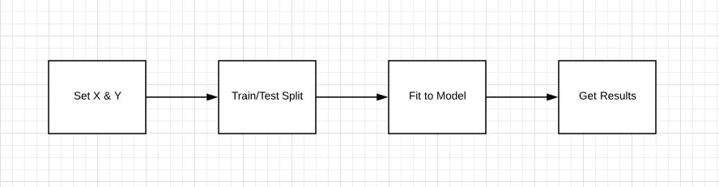

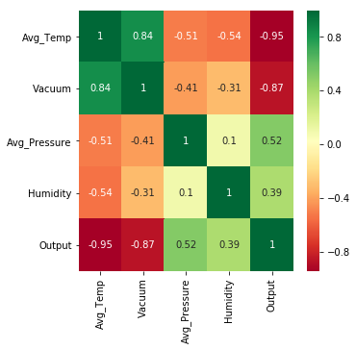
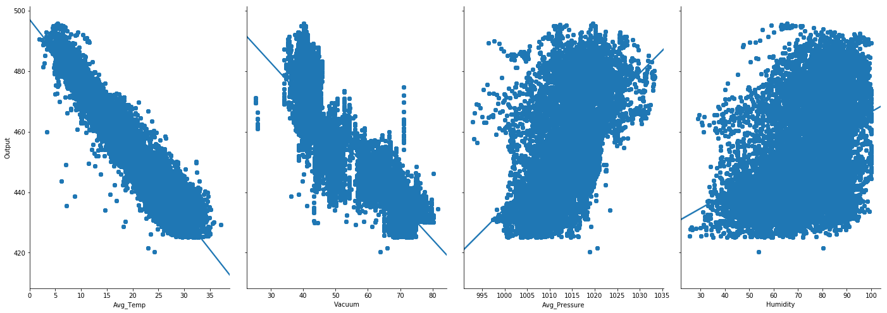

Results
The Results are as follows:
Mean Absolute Error: 3.585560841621613
Mean Squared Error: 20.264638560606443
Root Mean Squared Error: 4.501626212893119

Our Multivariate Linear Regression model was able to predict the output as the r2 score shows

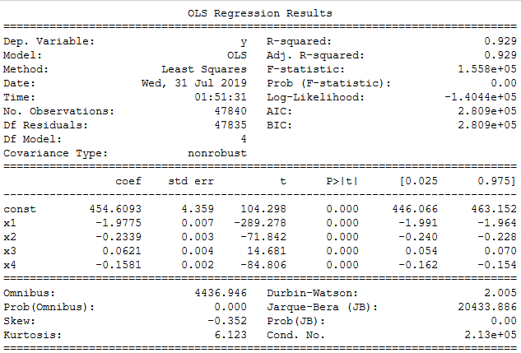

Conclusion

- Need more data: We need to have a huge amount of data to get the best possible prediction.

- Bad assumptions: We made the assumption that this data has a linear relationship, but that might not be the case. Visualizing the data may help you determine that.

- Poor features: The features we used may not have had a high enough correlation to the values we were trying to predict.

References
[1] A. Dehghani Samani, “Combined cycle power plant with indirect dry cooling tower forecasting using artificial neural network,” Decis. Sci. Lett., vol. 7, no. 2, pp. 131–142, 2018.

[2] A. Khosravi, S. Nahavandi, and D. Creighton, “Prediction intervals for short-term wind farm power generation forecasts,” IEEE Trans. Sustain. Energy, vol. 4, no. 3, pp. 602–610, Jul. 2013.

[3] C. Boccaletti, G. Cerri, and B. Seyedan, “A Neural Network Simulator of a Gas Turbine With a Waste Heat Recovery Section,” in Journal of Engineering for Gas Turbines and Power, 2001, vol. 123, no. 2, p. 371.

[4] E. Rich and K. Knight, “Artificial intelligence,” McGraw-Hill, New, 1991. M. Young, the Technical Writer’s Handbook. Mill Valley, CA: University Science, 1989.

[5] P. R. Norvig and S. A. Intelligence, “A modern approach,” Manuf. Eng., vol. 74, no. 3, pp. 111–113, 1995.

[6] R. POWER, “Combined Cycle Power Plant CCPP.” 2011.

[7] “Six_Sigma.” [Online]. Available:
https://en.wikipedia.org/wiki/Six_Sigma.

[8] V. Ramireddy, “An Overview of Combined Cycle Power Plant,” 2015. [Online]. Available: http://electricalengineering-portal.com/an-overview-of-combi ned-cycle-power-plant.

[9] T. Mahmoud, Z. Y. Dong, and J. Ma, “An advanced approach for optimal wind power generation prediction intervals by using self-adaptive evolutionary extreme learning machine,” Renew. Energy, vol. 126, pp. 254–269, Oct. 2018.

[10] U. Kesgin and H. Heperkan, “Simulation of thermodynamic systems using soft computing techniques,” Int. J. Energy Res., vol. 29, no. 7, pp. 581–611, 2005. J. Clerk Maxwell, A Treatise on Electricity and Magnetism, 3rd ed., vol. 2. Oxford: Clarendon, 1892, pp.68–73.

